Kingwood Area Alumnae Panhellenic Association
Spring 2016
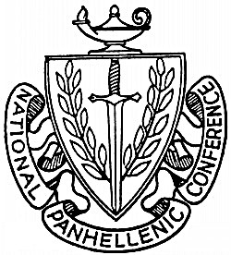

Dear Collegians:

The Kingwood Area Alumnae Panhellenic Association is pleased to offer a scholarship grant to a worthy, active sorority member from the Kingwood, Texas area. Since 1986, over 49 sorority women have been awarded these scholarship grants.

Applicants for this grant must meet the following criteria to be eligible for consideration:

- Cumulative GPA must be at least a 2.5 on a 4.0 scale.
- Must have been an active, initiated member for at least six months.
- Must submit one letter of recommendation from a chapter advisor, officer, and/or fellow collegian, outlining your qualifications, academic performance, sorority involvement, campus activities, and financial need.
- Must submit a letter describing in 150 words or less why you need this grant.
- Must submit completed application and required letter to the following address, postmarked by 5/1/16.

Carol-Leigh Harvey
22761 Whispering Timbers Way
Porter, Texas 77365

Applicants will be notified of the decision of the Scholarship Committee by June 1, 2017.

Please contact Carol-Leigh Harvey (information below) with questions.

In the spirit of Panhellenic,

Carol-Leigh Harvey
Panhellenic Scholarship Chairman
281-798-0109
carolleighharvey@gmail.com

